U18CO018

Shubham Shekhaliya

Assignment – 3

Operating System

1-> Write a shell script, which finds the prime factors of a given number.

Code:-

read -p $'Enter a number\n' num

for (( i = 2; i <= "$num"; i++))

do

    if (("$num" % "$i" == 0)) && (("$num" > 0))

    then

        echo "$i"

        while (("$num" % "$i" == 0)) && (("$num" > 0))

        do

            num="$(($num/$i))"

        done

    fi

done

Output:-

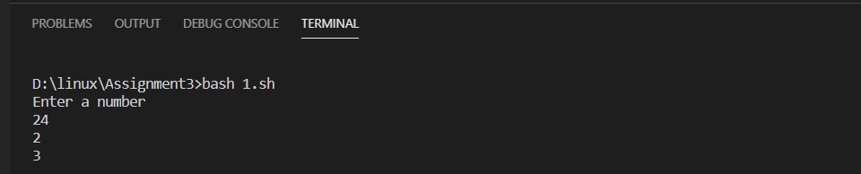

2-> Write a shell script that accepts a positive integer value from the user, say 34, and prints out

all the divisors of 34 as a list:

Enter a positive integer: 34

The divisors of 34 are: 1, 2, 17, and 34

Code:-

read -p "Enter a positive integer: " num

li=()

for (( i = 1; i <= "$num"; i++ )); do

    if [[ "$num"%"$i" -eq 0 ]]; then

        li+=($i)

    fi

done

echo -n "The divisors of $num are: "

echo "${li[@]}" | tr ' ' ,

Output:-

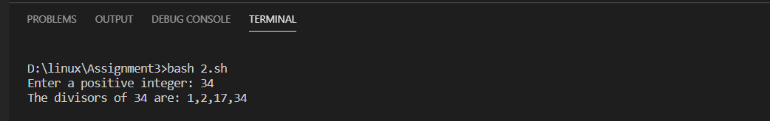

3-> Write a shell script, which prints good morning or good evening depending on the login time of the user.

Code:-

t=$(date +%T)

if [[ "$t" > "16:00:00" ]]; then

    echo "Good Evening"

else

    echo "Good Morning"

fi

Output:-

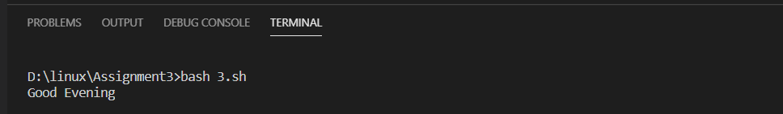

4-> A shell script, which takes as command line input a number n, and a word. It then prints the word n times, once on each line.

Code:-

for (( i = 0; i < "$1"; i++ )); do

    echo "$2"

done

Output:-

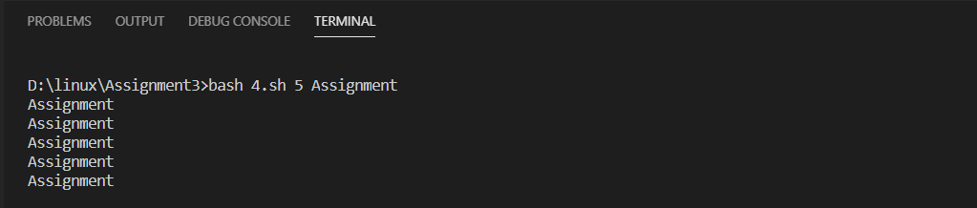

5-> Write a shell script, which finds the total number of blank lines in the given file.

Code:-

echo 'Enter file name'

read file

grep -cvP '\S' $file

Output:-

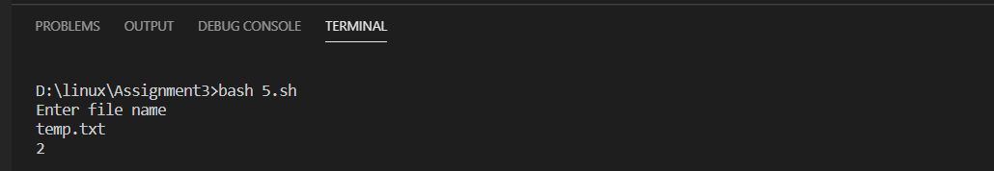

6-> A shell script, which reports the names and sizes of all the files in a directory whose size exceeds 1000 bytes, in descending order of their sizes and the total number of such files.

Code:-

ls -l | awk '$5 >= 1000 {print $9,$5}' | sort -k 2 -nr| tee >(wc -l)

Output:-

